Applied Data Science Project

The Battle of Neighborhoods – Project Report

Problem Background

The City of New York is a multicultural and diverse city in the United States. Starting a new business in a city like New York can be quite challenging and it the right factors are not considered, then there is a high chance that the business can get tricky.

Hence a lot of factors are analysed before starting up a new business and the analysis helps in coming to a proper conclusion, on how the different factors can affect the business.

Problem Description

The Project is targeted at people who are interested in starting a new business in the city of Toronto,New York. Toronto is a city with a wide varienty of food options available. It includes Indian, Italian, Middle Eastern, Chinese etc. Starting a new business in such a competitive environment can be challenging. Hence it is important to start the new business strategetically.

Tagret Audience
The project specifically focusses on people who want to start a restaurant business in New York City

Importance of the project

The projects takes into consideration different factors like
-Population
-Availability of Raw Materials
-Competitors
-Type of resturants in the area
-Type of customers in the area etc
Hence it helps the stakeholders to start the right business in the right location, so as to make the best out of the business.

Data Sources

Dataset 1:
The dataset which contains a total of 5 boroughs and 306 neighbourhoods in New York City.
The dataset also contains the latitude and longitude cordinates of each neighbourhood.Link to Dataset : https://geo.nyu.edu/catalog/nyu_2451_34572
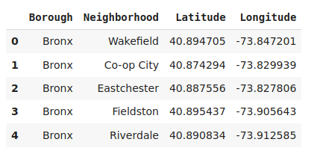

Dataset 2:
The dataset contains the list of Farmer Markets in NYC. The dataset is a part of the website GrowNYC.
https://data.cityofnewyork.us/dataset/DOHMH-Farmers-Markets-and-Food-Boxes/8vwk-6iz2
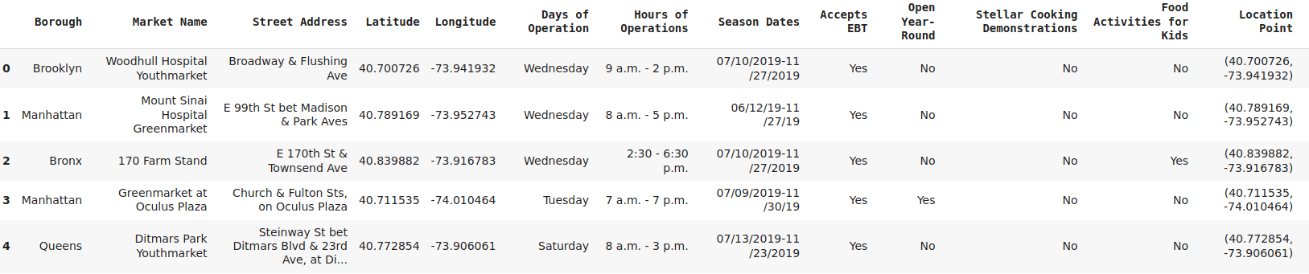
Dataset 3:
Economy of New York City
https://en.wikipedia.org/wiki/Economy_of_New_York_City
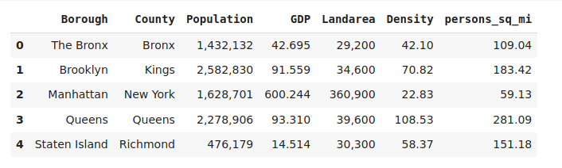

Dataset 4:
Cusines in New York
https://en.wikipedia.org/wiki/Cuisine_of_New_York_City

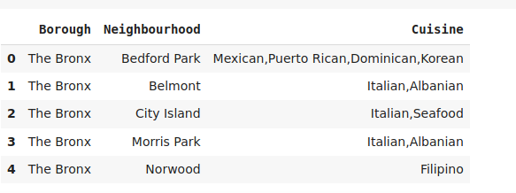

Dataset 5:

List of restaurants . It is obtained by using the FourSquare API.

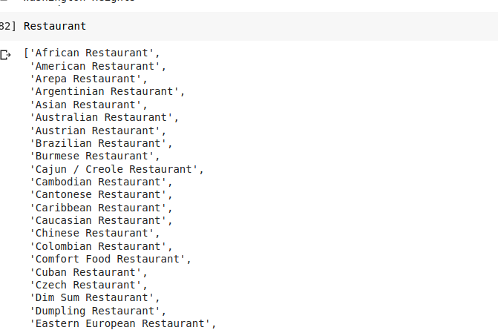

Analytic Approach

Visualizing the data in Brooklyn and Manhattan
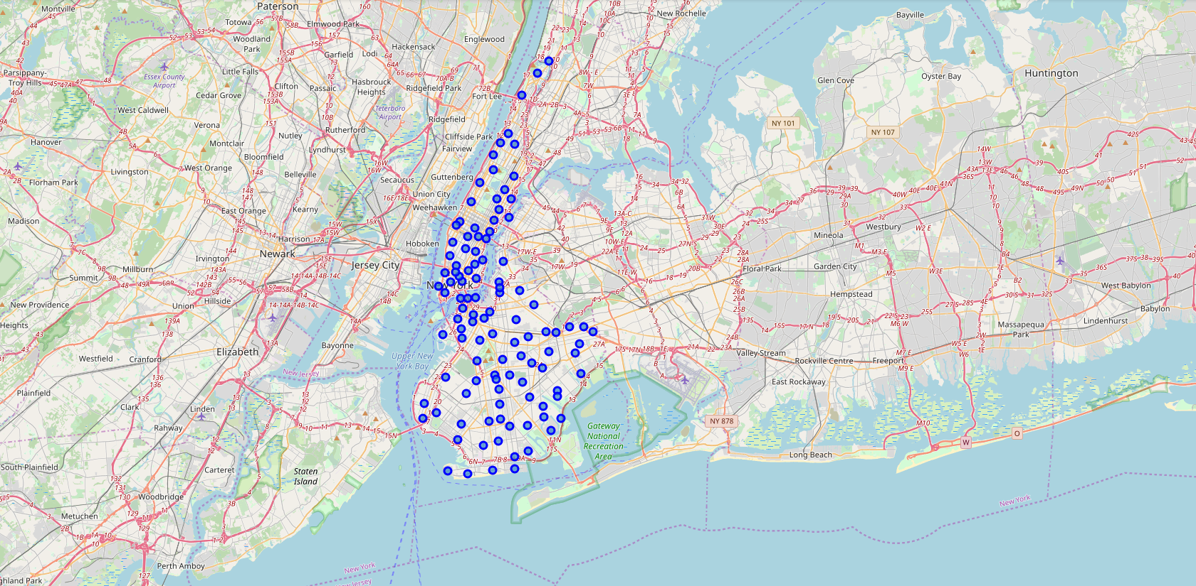

Getting the list of Nearby restaurants by filtering the foursquare results
After collecting data from all the sources we use Kmeans clustering to create clusters.
The number of clusters which are needed are found by calculating the Silhoutte Coefficient and we have found that for 2 clusters we have the highest values of Silhoutte Coefficient.

The Clusters are then analysed to see if there are any Untapped Markets in the neighbourhood.

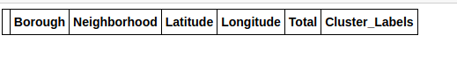

After the analysis, there were no untapped markets in Brooklyn and Manhattan.

Now the same excercise is repeated for the remaining 3 neighbourhoods.
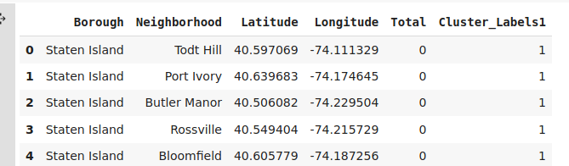

Conclusion

Based on the analysis, there is scope to increase the Farmers Markets and also possibility to start restaurants of various cuisines in Bronx, Queens and Staten Island.

